Lab 06: Operational Amplifier Circuits
Objective:
This lab gave experience in working with basic operational amplifiers using the LM 741 chip.

Introduction:
There were four parts to this lab. Each part gives us the voltage gain in an equation format and shows us various reasons as to why the output changes. We are also able to test how to affect the output during this lab.

Part 1: Non-inverting Amplifier:
- Method: We constructed the circuit as shown in the diagram. After this we did parts a-h. Please see the results below.

- Circuit diagrams:

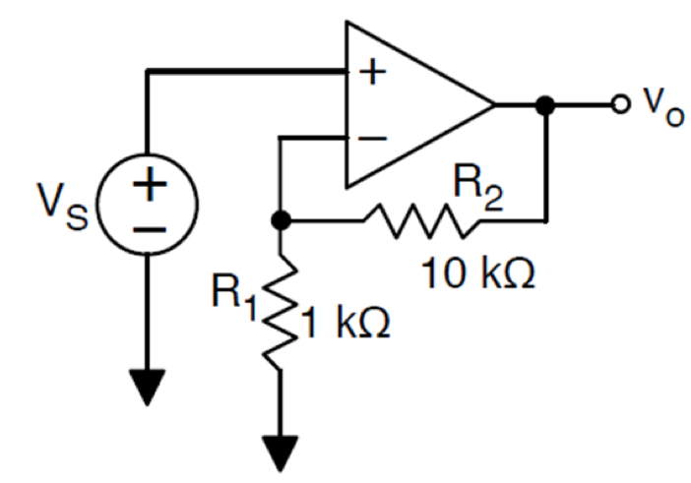

- Waveform snapshots:

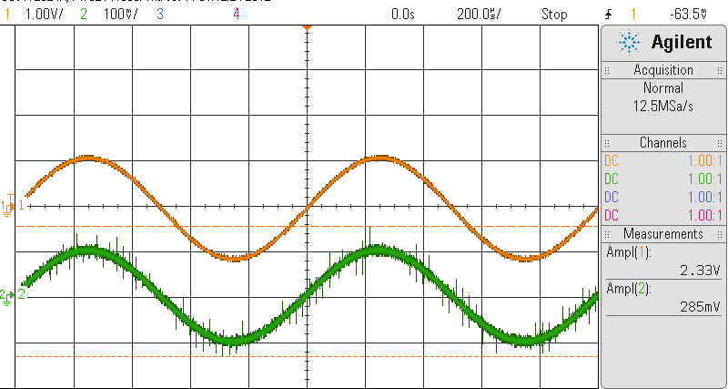
Above Image: Part D

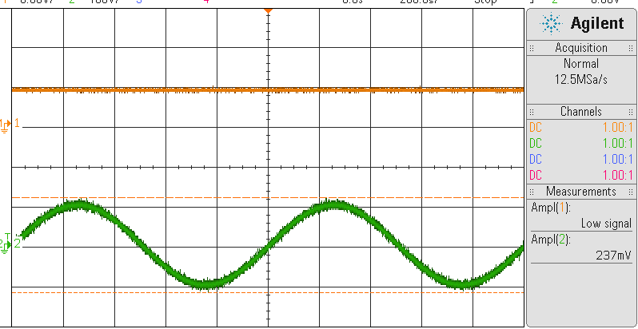
Above Image: Part F

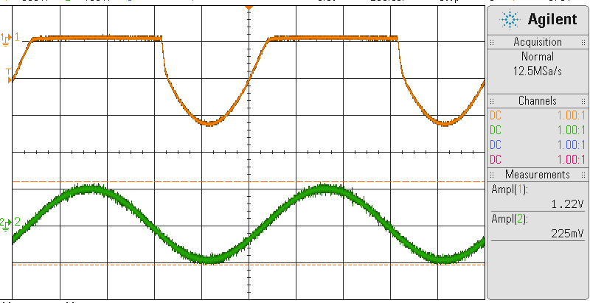
Above Image: Part G

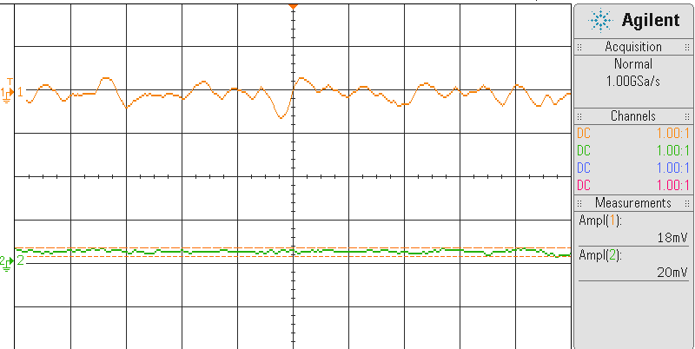
Above Image: Part H

- Results/ Discussion:

- The theoretical voltage gain: Av= 1+R2/R1= 1+10k/1k= 11 V/V.
- We built the circuit shown above. We used the VDD= +5/-5 V as the chip’s power supply. Also, the input signal is d.c. voltage at 100mV.
- We used the multimeter to find input voltage, which is .09V. Also, the output voltage is 1.012V. The voltage gain is Vo/Vs= 11.2 V/V
- In this part, we changed the input signal to an a.c. sinusoidal signal of 100mVpp at 1kHz. The input and output waveforms can be seen above. 2.33/.28=8.32 V/V. This makes sense because 8.32V must be less than 11 V/V.
- Comparing the experimental voltage gains measured from part 1c and 1d, you can see that the value of 1c is 11 V, which is the theoretical voltage gain. Part d is found to be 8.32 V/V. This is correct, because 11 V/V is the dc gain, so frequency is increasing. Therefore, the a.c. gain is less than 11 V/V.
- We continued with the same circuit as in part 1d. After grounding the negative power supply pin, we found that the ouput waveform seems to turn into a DC power after grounding. This voltage is found to be 4.235 Vdc.
- Next, we grounded the positive power supply pin and connected back the negative power supply pin to -5 V. The shape of this output waveform can be found above. It becomes clipped.
- What happens when the ouput when both power supplies pins are grounded is that there is no power supply through the amplifier, so Vout is basically Vs. As you can see from the photo, Vout=18mV & Vs=20mV.

Part 2: Inverting Amplifier:
- Method: We constructed the circuit as shown in the diagram. After this we did parts a-h. Please see the results below.

- Circuit diagrams:

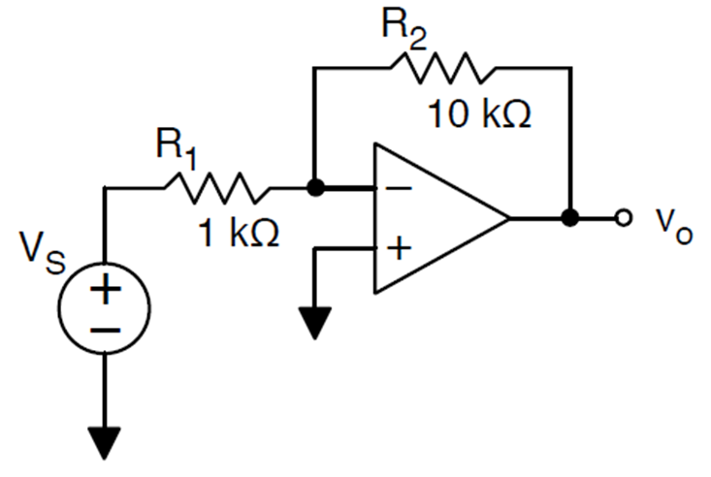

- Waveform snapshots:
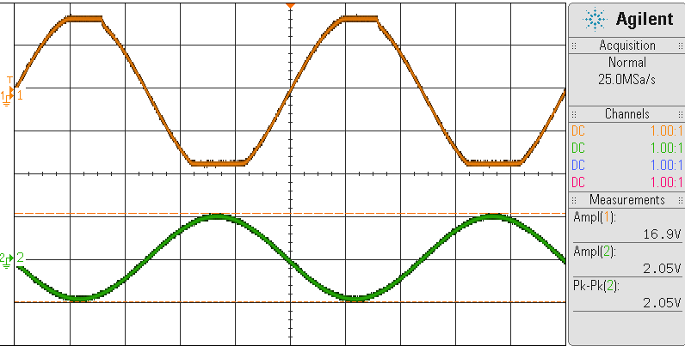
Above Image: Part F

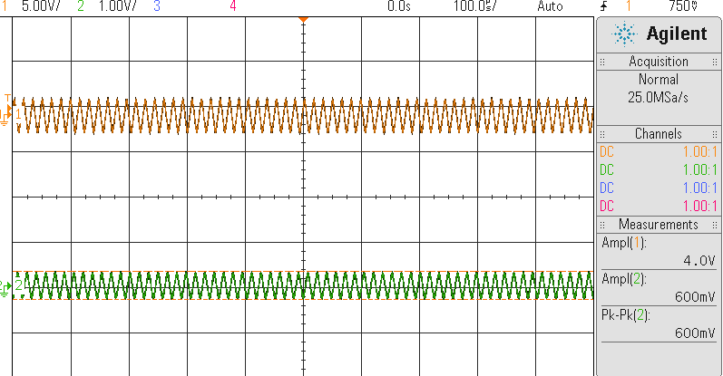
Above Image: Part G

- Results/ Discussion:
- The theoretical voltage gain of the amplifier is Av= -R2/R1= -10k/1k=-10V/V.
- We built the circuit given, and made the values of the power supplies VDD=+10V & VSS= -10V. The input signal is a d.c. voltage Vs. This Vs = +500mV.
- Using a multimeter, we found the input voltage to be 500mV and the output voltage was -4.98. The voltage gain is found to be Vo/Vs=-4.98/500mV= -10V/V.
- We changed the input signal to an a.c. sinusoidal signal of 500mVpp at 1kHz. The input and output waveforms can be found above. Vout=10.3 V & Vin=1.03 V. Therefore, the voltage gain: Vo/Vs=10.3/1.03= 10V/V.
- Both theoretical gain from 1a matches both part 1c and 1d.
- We continued with the same circuit in part 2d. The frequency is still at the same frequency of the input signal. We slowly increased the peak-to-peak amplitude of the input signal and observed the output waveform. This can be found above. It begins being clipped on both ends starting when the Vs=2.05 V. The Vout= 16.9 V. The relationship between the input voltage (where output clipping occurs) vs. the resistors (or amplifier gain) is as follows: Vs/Vo=R2/R1
- Vout=5.4V. The frequency of the input signal where the output power is half of the input power: 5.4/sqrt(2) = 3.8 V. This is where the voltage of the -3dB is or half of the input power. 62kHz is the frequency. Please see waveform image above. When we have 500mVpp input and 1kHz, the Vs=600mV.
- Next, we connected a resistor between the non-inverting pin and ground. The amplifier does not change. Next, we chose a 10kOhm and added it between the output and ground. The amplifier gain again does not change.

Part 3: Summing Amplifier:
- Method: We constructed the circuit as shown in the diagram. After this we did parts a-f. Please see the results below.

- Circuit diagrams:

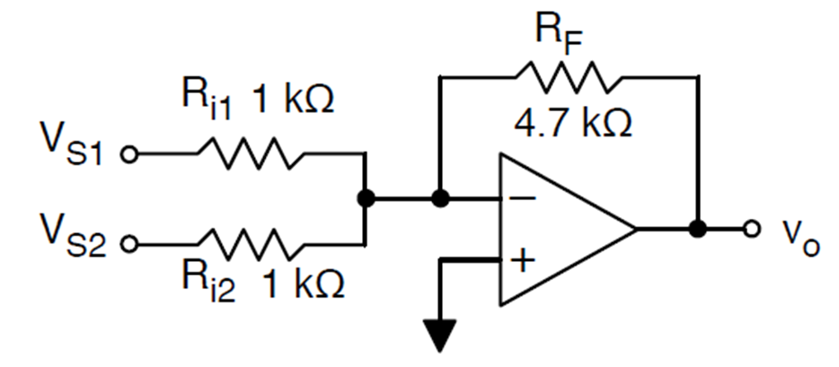

- Waveform snapshots:
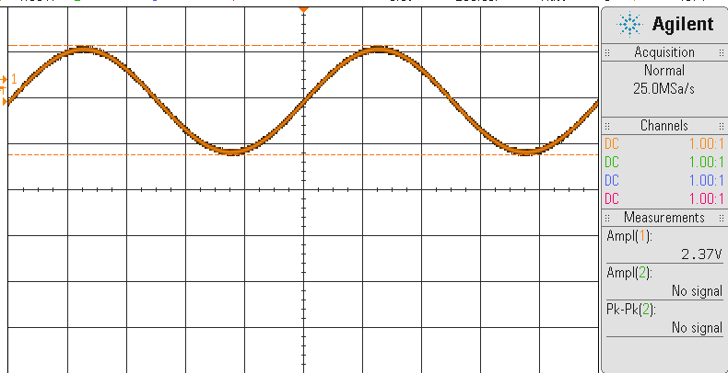
Above Image: Part D

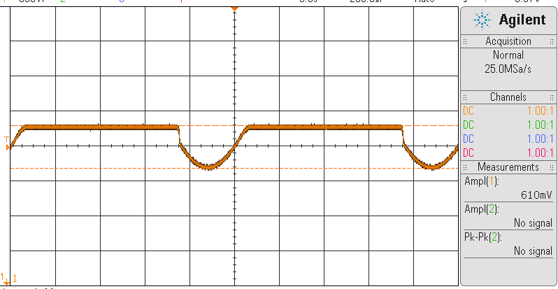
Above Image: Part F

- Results/ Discussion:
- The theoretical output voltage of this circuit can be found by: Av = (‐RF/Ri1)*Vs1 + (‐RF/Ri2)*Vs2. = -1.88 V/V.
- We built the circuit with the power supply being VDD= +10V and VSS=-10 V. We shoes Vs1= 100mV and Vs2= 300mV.
- Using the multimeter, we found the output voltage to be Vout= -1.842 V. This matches the theoretical voltage.
- We kept Vs1 as the same d.c. input voltage and then changed the second input Vs2 to an a.c. signal. Please see the above waveform for this part. Vout= 2.37V. Theoretically, we should have gotten 0.6*4.7= 2.82 V. These values are very close.
- Continuing with the same circuit as in part d, we kept Vs2 as the a.c. signal. We then slowly increased the amplitude of the d.c. input Vs1. At this point, the output waveform is “out of range” at 2V, therefore there is no signal.
- We continued with the same circuit as part e. The non-inverting pin is grounded. We then connected the non-inverting pint to +1.0. This extra d.c. voltage clips the waveform. See above image.
Part 4: Difference Amplifier:
- Method: We constructed the circuit as shown in the diagram. After this we did parts a-e. Please see the results below.

- Circuit diagrams:

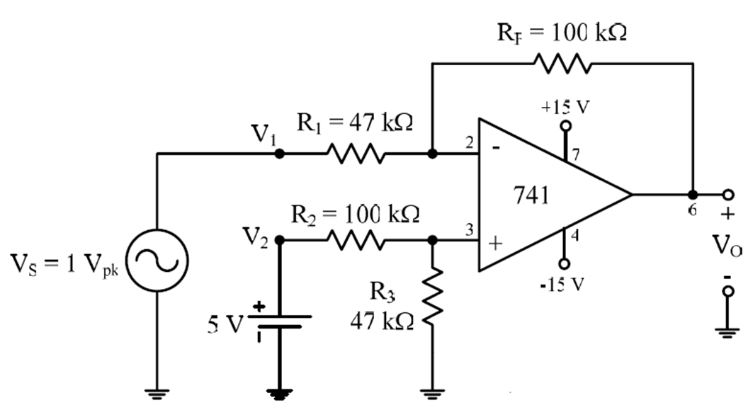

- Waveform snapshots:

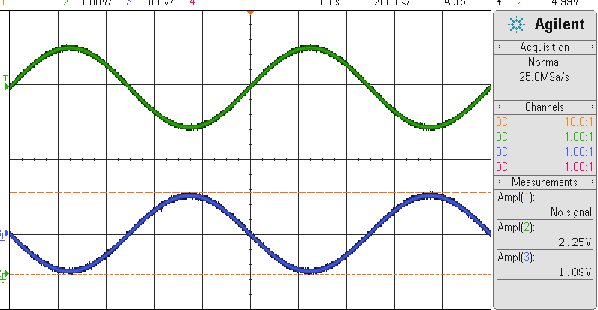
Above Image: Part C

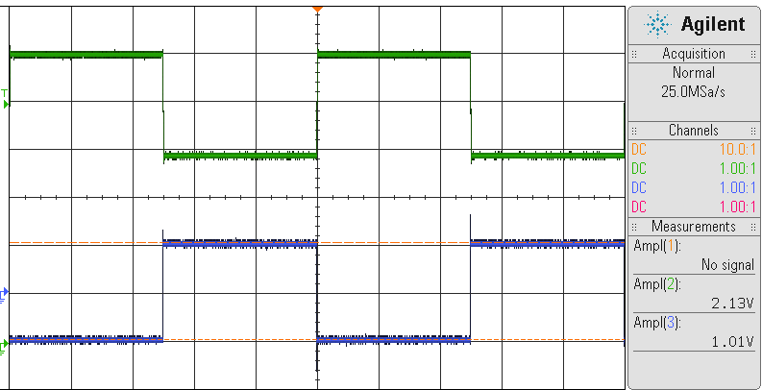
Above Image: Part D

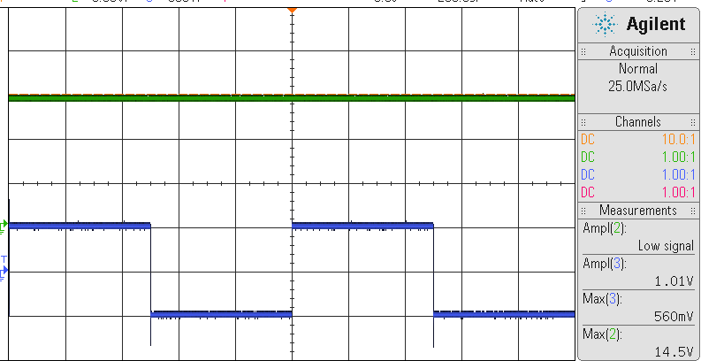
Above Image: Part E

- Results/ Discussion:
- The theoretical output voltage of the circuit can be found with: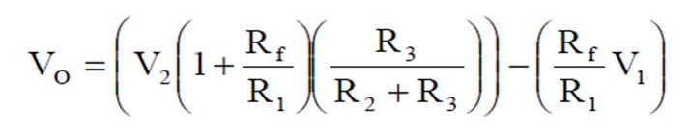= 2.87 V.
- We constructed the circuit given. The VDD=+15V and VSS=-15V. One input is a d.c. signal of 5V. The other input Vs. is an a.c. signal at 1Vpp at 1kHz.
- Please see the output waveform on the oscilloscope above. Vout= 2.3 V. This is close to the theoretical output voltage calculated in part a. The wave is shifted up by 5V.
- We kept the d.c. input at 5V and switched the a.c. input Vs to a square wave. Please see the output waveform above. This circuit does act as a difference amplifier.
- We removed resistor R3. The change in the output waveform and the theoretical output voltage is a d.c. offset shifted up by 14.5V.

Summary
Overall, this was a very educational laboratory. We were given experience with a Difference Amplifier, Summing Amplifier, Inverting Amplifier, and Non-Inverting Amplifier. We were able to observe how changing the resistors and circuit orientations change the output waveform. In addition, when we added voltages that were d.c. and/or a.c. we could change the input so that the output wave is shifted. This obviously depends on the value of the input voltage.

