Lab 05: Frequency Response of Operational Amplifiers
Objective:
The objective of this lab was to learn about bandwidth and how resistance affected the circuit’s bandwidth.

Introduction:
In this lab, we built the circuits given and took various measurements. We analyzed each circuit according the instructions. Below, you can view a picture of our actual circuit:
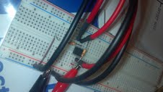
Non-inverting Amplifier 1 Results:
- Method: We constructed the circuit given and found the voltage gain. Next, we used the 1Vpp sine wave as the input to the circuit and measured the bandwidth. We did this by recording the frequency response of the amplifier. After this, we determined the gain-bandwidth product. Step 4 had us keep the input frequency at 1000 Hz and increase the amplitude of the input sinewave signal starting at zero. We recorded the maximum amplitude of the output signal and the maximum amplitude of the input signal before the output becomes clipped. The step response and slew rate were then then measured. Please see all of the data below.

- Circuit diagrams:

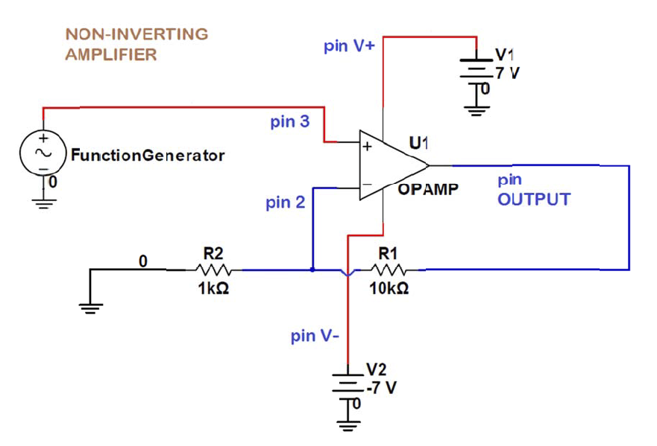

- Waveform snapshots: 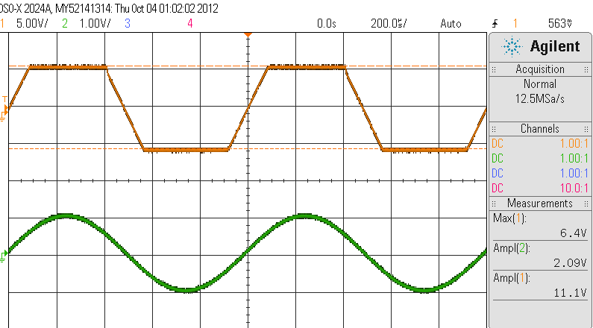
Above Image: Part 1, computing voltage gain which is 11.1 V/V

Step 2:
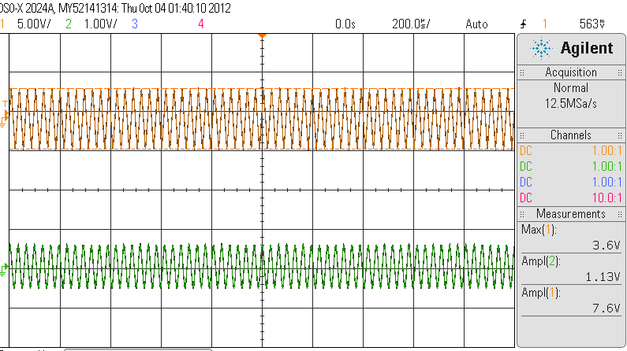
Above Image: At 7.6V, the frequency is at bandwidth. Clipping is no longer happening. The frequency here is 31 kHz.

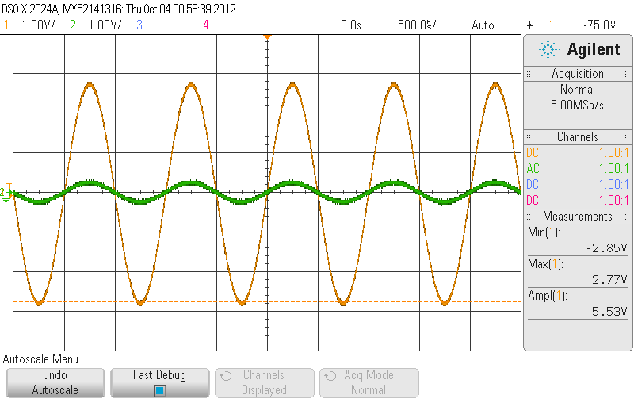
Above Image: Voltage out at 5.53 V.

- Results/ Discussion:
Step 1: To compute the voltage gain (Av = Vo/Vin): Vo= 5.53; Vin= .5; A = 11 V/V in decibels: 20.875 dB.

Step 2:
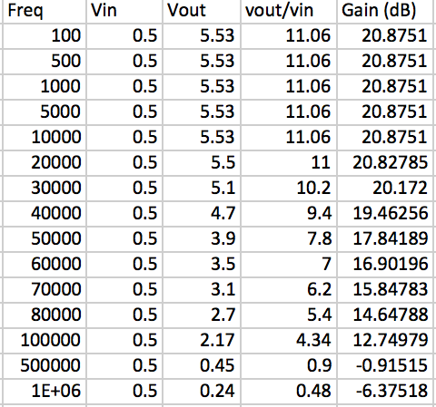
11/sqrt(2) = 7.82 bandwidth frequency close to this voltage
Above Table: Measuring Gain

The bandwidth was found to be 31000Hz.

Step 3: To determine the gain-bandwidth product, you multiply the gain and the bandwidth. 11*31000= 341000 Hz.

Step 4:
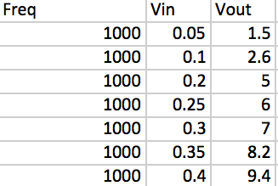 Clipping begins
Above Image: Transfer Plot

Step 5: Step response is the rise and fall time.

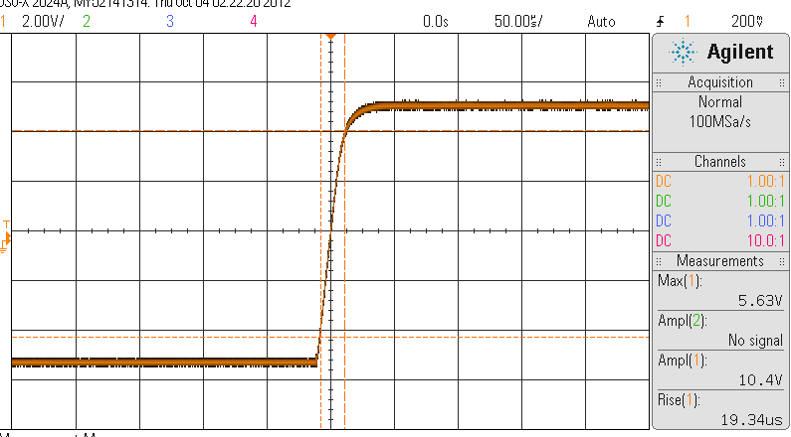
Above Image: Rise Time is 19.3us.

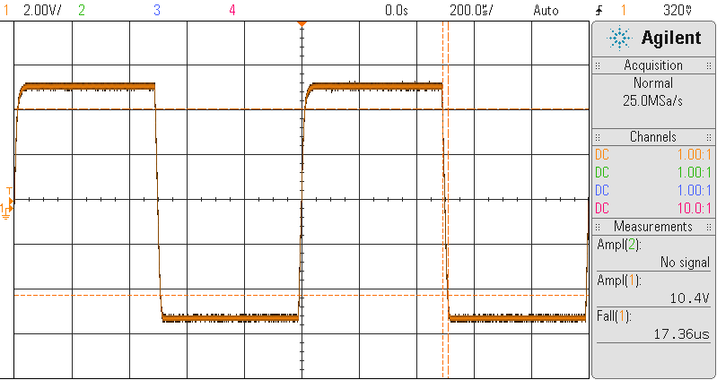
Above Image: Fall time is 17.4us

As you can see, the rise and fall time are very close. There is a 1.9 second difference. The slew rate can be found by 2*pi*frequency*Vout or the Amplitude/rise time = .5361 V/us. This is very close to the .5 V/us value mentioned in the instructions.

Step 6: The pole location of the amplifier is found by W_{pole}=-2*pi*f_{-3dB}. In this case, the f_{-3dB} value is 31kHz. Therefore, the pole location is -194778.7. There is just one pole. Its transfer function is:
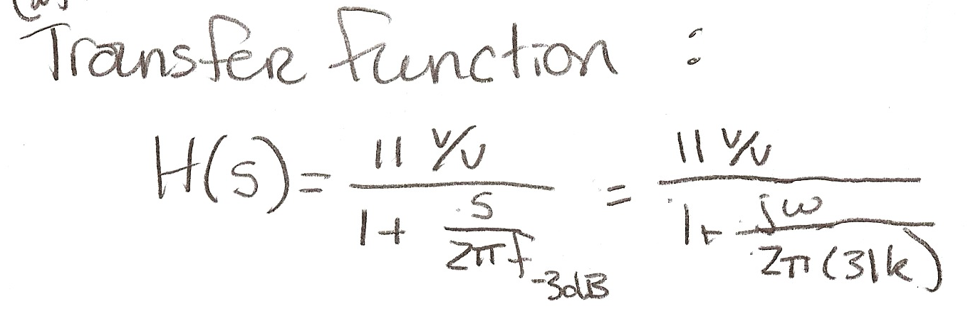
Below, you can find the relationship between the rise time of the step response to the pole location of the amplifier:
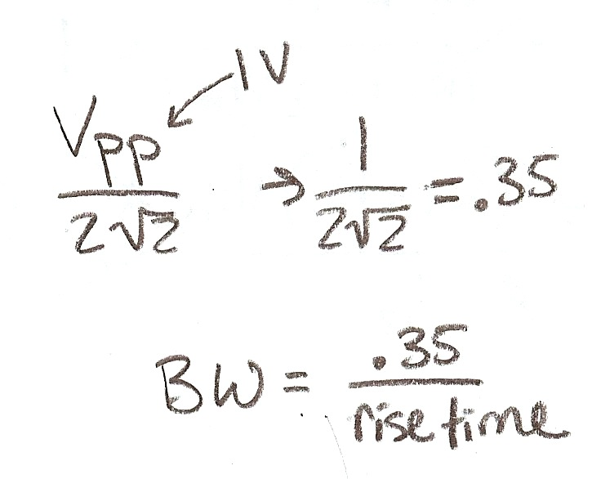

Non-inverting Amplifier 2 Results:
- Method: The method for the 2nd non-inverting amplifier was the same as the first except with different resistors. We constructed the circuit given and found the voltage gain. Next, we used the 1Vpp sine wave as the input to the circuit and measured the bandwidth. We did this by recording the frequency response of the amplifier. After this, we determined the gain-bandwidth product. Step 4 had us keep the input frequency at 1000 Hz and increase the amplitude of the input sinewave signal starting at zero. We recorded the maximum amplitude of the output signal and the maximum amplitude of the input signal before the output becomes clipped. The step response and slew rate were then measured. Please see all of the data below.

- Circuit diagrams:

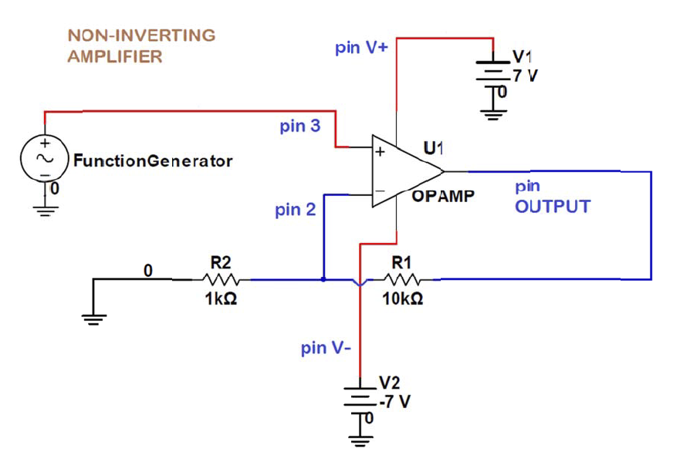

- Waveforms:
- Results/ Discussion:

Step 1: The voltage gain: Av= Vout/Vin= 6.2/1.09 = 6.2 V/V in decibels= 36.5 dB

Step 2:
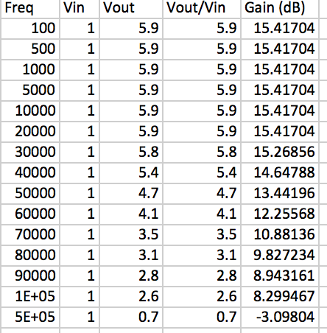
6.2/sqrt(2) = 4.4V bandwidth frequency close to this voltage
Above Table: Measuring Gain

The bandwidth was found to be 20 kHz.

Step 3: Gain-bandwidth product is 6.2* 20000= 124000.

Step 4:
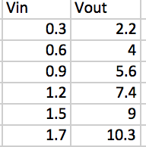Begins Clipping

Step 5: 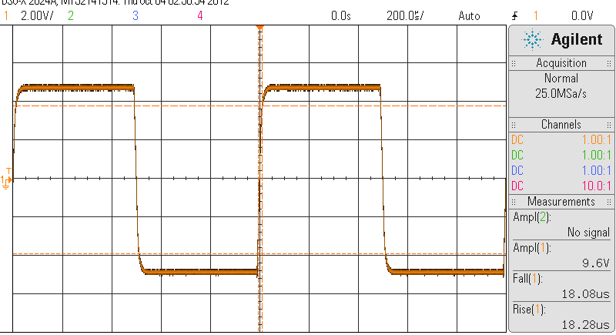
Above Image: Rise time is 18.28us & fall time is 18.08us.

The difference between rise and fall time is .20 seconds, making them very similar. The slew rate is Vout/Rise Time = 9.6/18.28= .525 V/us. This is close to the expected .5 V/us.

Step 6: The pole location of the amplifier is found by Wpole=-2*pi*f_{-3dB}. In this case, the f_{-3dB} value is 20kHz. Therefore, the pole location is -125663.7. There is just one pole. Its transfer function can be seen below:
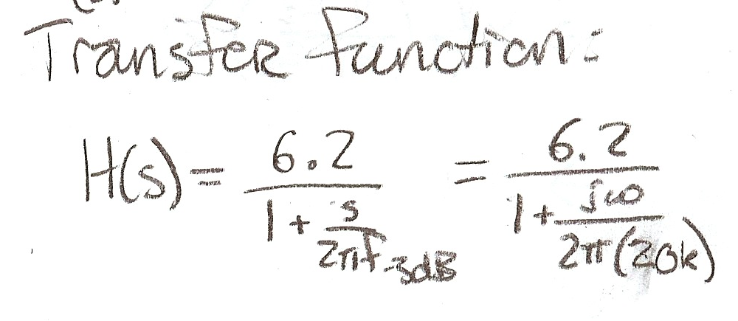
The relationship between the pole location and the rise time is that the pole location is found below:
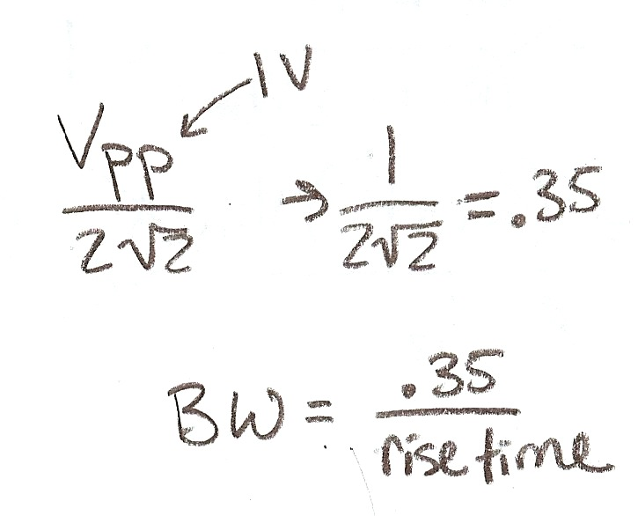

Summary:
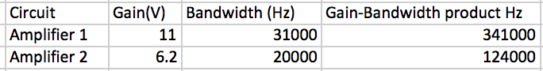
Above Image: Please see the summarized differences between the two amplifier circuits.

