Lab 03: RC Circuits, High-pass and Low-pass
Objective
The objective of this lab was to make us familiar with the characteristics of different RC circuits whether they are high-pass, low-pass, or band-pass.

Introduction:
In lab 3, we made an RC filter with a transfer function. We then found how to measure the phase shift, plot the magnitude vs. frequency, and then plot the phase vs. frequency. A bandpass filter is a device that passes frequencies within a certain range and rejects frequencies outside that range. As you will see later in this lab report, we constructed a bandpass filter.

Part 1 Results:
- Method: For the first part, we constructed a passive RC filter with the transfer function: 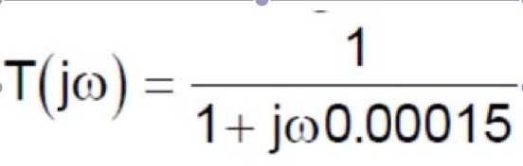. We used a 15k Ohm resistor and .01u F capacitor. We measured the amplitude/ magnitude and phase shift for various frequencies using the oscilloscope. The following figure is an example of how we could find the phase shift: 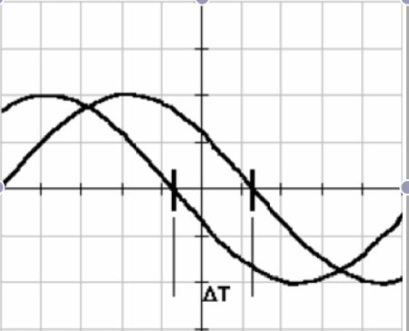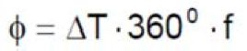

After we found those two aspects, we plotted the magnitude (in dB) vs. frequency and phase vs. frequency for all data found.

- Circuit diagrams:

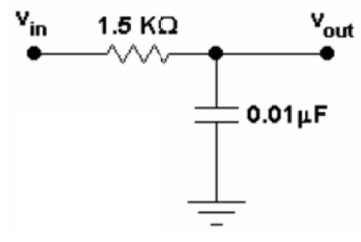

- Waveform snapshots: I have included a variety of waveforms for this section so it is clear how we found the amplitude and phase shift of each frequency measurement.
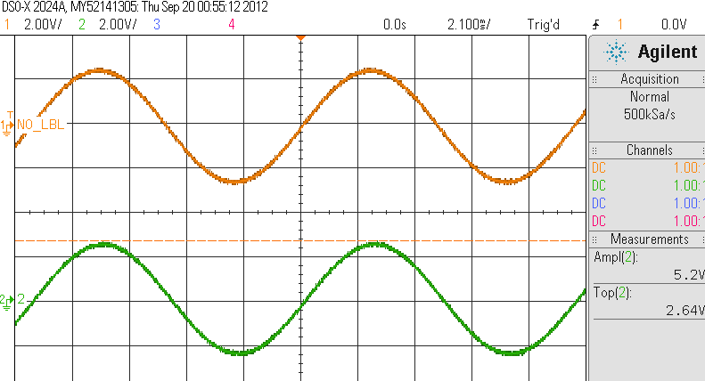
Above Figure: Measurement of amplitude for 5 Volts at 100 Hz.
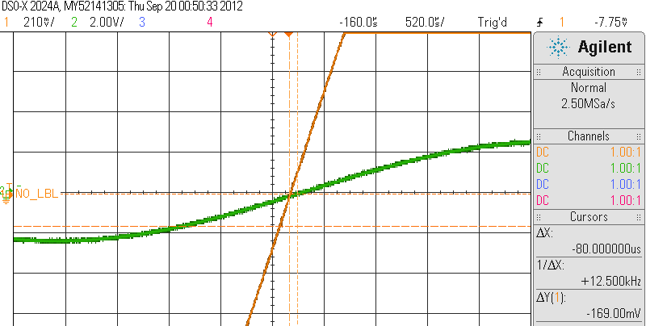
Above Figure: Measuring the phase shift of Vout at 100Hz.

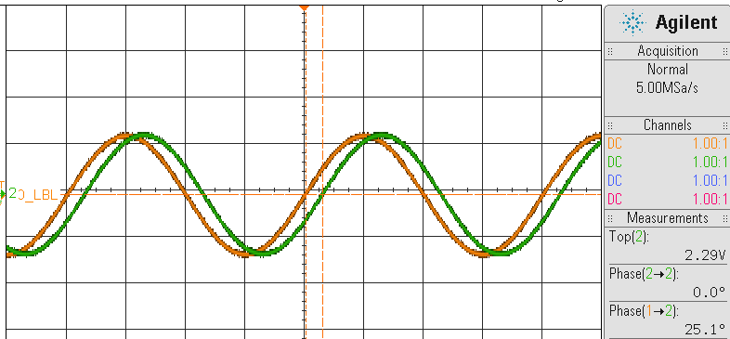
Above Figure: Measuring the phase shift of Vout at 500Hz.

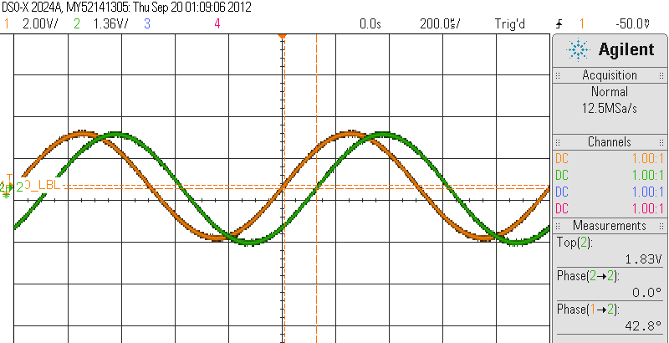
Above Figure: Measuring the phase shift of Vout at 1kHz.

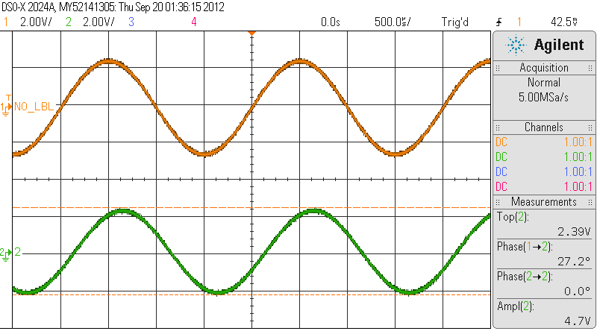
Above Figure: Measuring the magnitude of Vout at 500Hz.

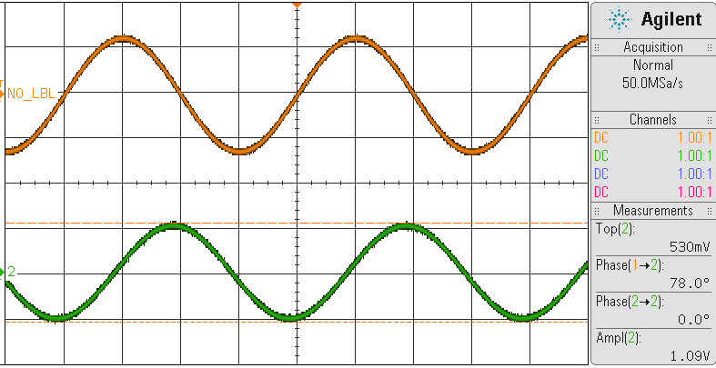
Above Figure: Measuring the magnitude of Vout at 5kHz.

- Results/ Discussion: In the circuit, the measured resistor value was found to be 14.8kOhms. We modified the input voltage to 5 Volts so we could have a better reading of our data. We found ΔT to be -80us for 100Hz. Therefore, using the equation: , we found the phase shift to be -2.88 degrees. Please see the other data found for the various frequencies below. As you can see, the magnitudes and phase shifts are comparable with the waveforms found above.

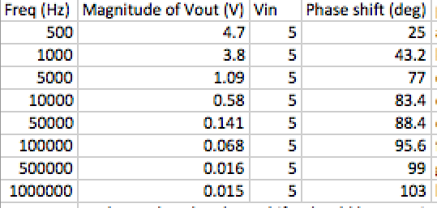

This type of circuit is known as low pass. A Low Pass filter is a filter that passes low frequencies and attenuates high frequencies. The amplitude response of a low pass filter is flat from DC or near DC to a point where it begins to roll off. A standard reference point for this roll-off is the point where the amplitude has decreased by 3 dB, to 70.7% of its original amplitude. The amplitude of the filter at ten times the -3 dB frequency is attenuated a total of -20 dB for the pole of the filter. The phase response of a low pass filter doubles. The change in phase of a single pole filter is 45 degrees at the 3 dB frequency, and in the end gets to 90 degrees at infinity. As you can see in this experiment, the phase shift was found to be a little higher than 90 degrees, but that is all relative to experimental error.

Part 2 Results:
- Method: Part 2 involved repeating all of the steps of part 1 for a different, high-pass circuit.

- Circuit diagrams:
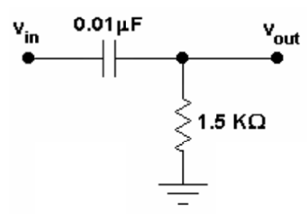

- Waveform snapshots: Please view Part 1’s waveforms to see how measurements were taken.

- Results/ Discussion: In this circuit arrangement is found to be a high pass filter. High pass filter circuit only passes signals above the selected cut-off point (Fc) eliminating any low frequency signals from the waveform. The reactance of the capacitor is very high at low frequencies so the capacitor acts like an open circuit and blocks any input signals at Vin until the cut-off frequency point, fc, is reached.

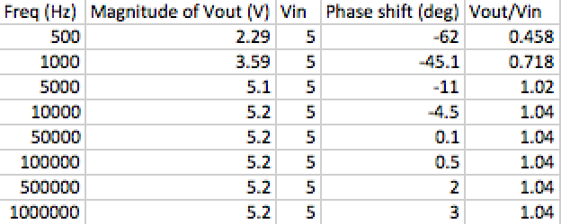

Part 3 Results:
- Method: For Part 3, we designed a bandpass filter with a zero at 0 Hz, and two corner frequencies: one at 1kHz and the other at 100kHz. We selected R1, R2, C1, and C2 to get the desired response in the circuit below. Pspice simulation was then involved. After Pspice, we measured the two corner frequencies and center frequency.

- Circuit diagrams:

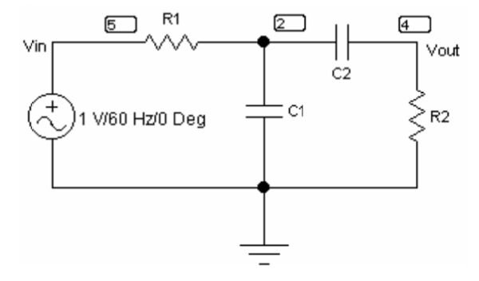
Above Figure: Given bandpass filter.
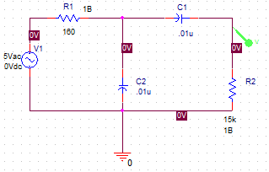
Above Figure: Pspice circuit stimulation with found resistor and capacitor values.

- Waveform snapshots: N/A

- Results/ Discussion: A band pass filter passes signals within a certain "band" or "range" of frequencies without messing up the input signal. This band of frequencies can be any width and is commonly known as the filter’s Bandwidth. Bandwidth is defined as the frequency range between two specified frequency cut-off points (aka fc) that are 3dB below the maximum centre or resonant peak while weakening the others outside of these two points. In this experiment, I found the corner frequencies very close to 1kHz and 100kHz. The center frequency was found at 10kHz. The reason for differences between the Pspice simulation and the experimental measurements may have been the true values of the resistors and the capacitors used in the experiment. Please see my reasoning below for using the values of resistors and capacitors that I did use:
